COAL – Lab 9 – Lab tasks

Task 1:
INCLUDE Irvine32.inc

.data
value BYTE ?
key BYTE ?
encrypted BYTE ?
decrypted BYTE ?
prompt1 BYTE "Enter value (0-255): ",0
prompt2 BYTE "Enter key (1-7): ",0
msg1 BYTE "Encrypted value: ",0
msg2 BYTE "Decrypted value: ",0

.code
main PROC
mov edx, OFFSET prompt1
call WriteString
call ReadInt
mov value, al

mov edx, OFFSET prompt2
call WriteString
call ReadInt
mov key, al

mov al, value
mov cl, key
rol al, cl
mov encrypted, al

mov edx, OFFSET msg1
call WriteString
movzx eax, encrypted
call WriteInt
call CrLf

mov al, encrypted
mov cl, key
ror al, cl
mov decrypted, al

mov edx, OFFSET msg2
call WriteString
movzx eax, decrypted
call WriteInt
call CrLf

exit
main ENDP
END main

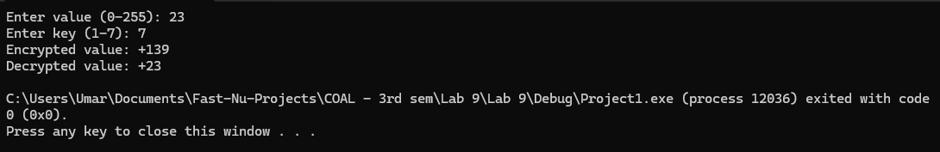

Task 2:
INCLUDE Irvine32.inc

.data
a DWORD ?
b DWORD ?
sum1 DWORD ?
sum2 DWORD ?
diff1 DWORD ?
diff2 DWORD ?
msg1 BYTE "Enter first number: ",0
msg2 BYTE "Enter second number: ",0
m1 BYTE "Result of ADD: ",0
m2 BYTE "Result of ADC: ",0
m3 BYTE "Result of SUB: ",0
m4 BYTE "Result of SBB: ",0

.code
main PROC
mov edx, OFFSET msg1
call WriteString
call ReadInt
mov a, eax

mov edx, OFFSET msg2
call WriteString
call ReadInt
mov b, eax

mov eax, a
add eax, b
mov sum1, eax

stc
mov eax, a
adc eax, b
mov sum2, eax

mov edx, OFFSET m1
call WriteString
mov eax, sum1
call WriteInt
call CrLf

mov edx, OFFSET m2
call WriteString
mov eax, sum2
call WriteInt
call CrLf

mov eax, a
sub eax, b
mov diff1, eax

stc
mov eax, a
sbb eax, b
mov diff2, eax

mov edx, OFFSET m3
call WriteString
mov eax, diff1
call WriteInt
call CrLf

mov edx, OFFSET m4
call WriteString
mov eax, diff2
call WriteInt
call CrLf

exit
main ENDP
END main

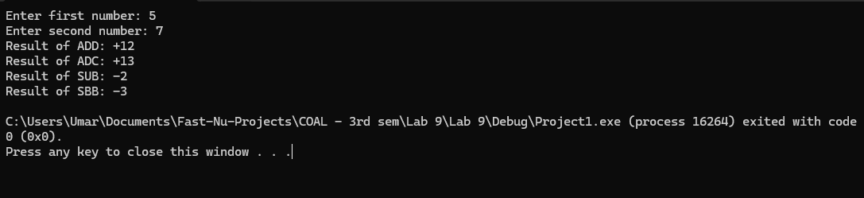

Task 3:

INCLUDE Irvine32.inc

.data
byteVal SBYTE ?
wordVal SWORD ?
msg1 BYTE "Enter first negative number (byte): ",0
msg2 BYTE "Enter second negative number (word): ",0
m1 BYTE "Extended to word: ",0
m2 BYTE "Extended to dword: ",0

.code
main PROC
mov edx, OFFSET msg1
call WriteString
call ReadInt
mov byteVal, al

mov edx, OFFSET msg2
call WriteString
call ReadInt
mov wordVal, ax

mov al, byteVal
cbw
movsx eax, ax
mov edx, OFFSET m1
call WriteString
movsx eax, byteVal
call WriteInt
call CrLf

mov ax, wordVal
cwd
cwde
mov edx, OFFSET m2
call WriteString
movsx eax, wordVal
call WriteInt
call CrLf

exit
main ENDP
END main

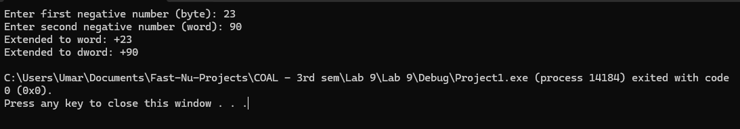

Task 4:

INCLUDE Irvine32.inc

.data
num DWORD ?
n BYTE ?
mulRes DWORD ?
divRes DWORD ?
msg1 BYTE "Enter a number: ",0
msg2 BYTE "Enter n: ",0
m1 BYTE "Result after multiplying by 2^n: ",0
m2 BYTE "Result after dividing by 2^n: ",0

.code
main PROC
mov edx, OFFSET msg1
call WriteString
call ReadInt
mov num, eax

mov edx, OFFSET msg2
call WriteString
call ReadInt
mov n, al

mov eax, num
mov cl, n
shl eax, cl
mov mulRes, eax

mov eax, num
mov cl, n
shr eax, cl
mov divRes, eax

mov edx, OFFSET m1
call WriteString
mov eax, mulRes
call WriteInt
call CrLf

mov edx, OFFSET m2
call WriteString
mov eax, divRes
call WriteInt
call CrLf

exit
main ENDP
END main

